RECIPE  
Vanilla Coffee Creamer

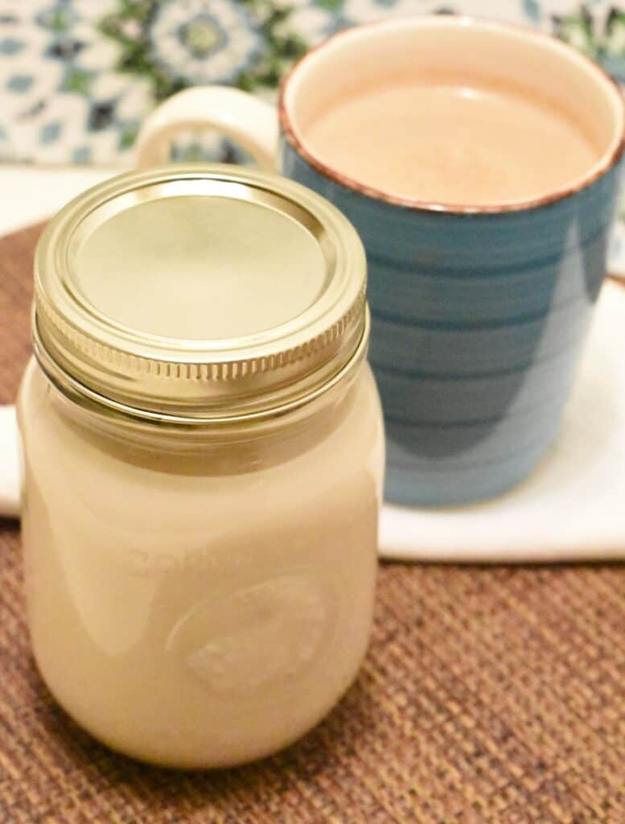

# Ingredients

* 14 oz milk (preferably whole)
* 14 oz sweetened condensed milk
* 1 tsp vanilla extract

# Preparation

1. Pour the three ingredients into a container and shake until well combined. Keep in a sealed container in the refrigerator.